**CHAPTER 1**

**INTRODUCTION**

* 1. **PURPOSE**

**“LATE COMMERS MAINTAINANCE SYSTEM**” is a application software and it is very helpful for the administration to view how many students are coming late to the college, how many students are comming late more than three times. By using this application administrators are easily find that particular student how many times he come late .

This application helps to the many schools and colleges to know about the details of students whose coming late to the college and also as well as college people also has to be seen the late commers details but administration will maintain this application.

* 1. **SCOPE**

**The scope of the project is as follows:**

* To learn about the stages of building a software project, like requirements, design, execution, testing and deployment.
* To learn about web page development and database connectivity between client side and server side in detail.
* To create a prototype web site focusing on one of the many problems that arises within maintaining student records
  1. **OVERVIEW**

An organized and systematic technical solution is essential for all universities and organizations. There are many departments of administration for the maintenance of college information and student databases in any institution. All these departments provide various records regarding students. Most of these track records need to maintain information about the students.

With that in mind, we came up with this project. Administrators of the system will enter the student information along with the details of the late commers. In general, this project aims to enhance efficiency and at the same time maintain information accurateness. Later in this report, features and improvement that allow achievement to this goal will be demonstrated and highlighted.

We have utilized the powerful database management, data retrieval which makes the data entered in the website reliable and stores it all securely. We will provide more ease for managing the data than manually maintaining in the documents. Our work is useful for saving valuable time and reduces the huge paper work.

**1.4 EXISTING SYSTEM**

Existing system is that the educational institutions maintain late commer student records in papers and files. To add a new data, lot of time and manual work is needed as we have to make a new entry in the record.

**DISADVANTAGES**

1. In colleges they have no some special website to maintain late comers datails.
2. It is very difficult to know the late commers details through papers.
3. The person who maintain late comers details in documents or in papers may not be available all the time.
4. Every year college get so many late comers records. it is very difficult to maintain their records.
5. Through this paper or documents lot of time will be wasted.

**1.5 PROPOSED SYSTEM**

This system maintains students’ information digitally in a structured database. This system is very helpful to college management easy to access the details of late commers and also the college administration to find the late commers.

**1.6 ADVANTAGES**

1. Modification and categorization of data is very easy.
2. No chance of redundancy in data stored.
3. It provides accurate data and also updating every semester or in a year.
4. Adding the data and retrieving the same is done within the seconds.

**CHAPTER 2**

**REQUIREMENT ANALYSIS**

**2.1 PROBLEM DEFINITION** The basic theme behind our proposed system is to provide a late coming students details. It is very useful to college management to maintain students details, our willing is to know whose coming late everyday and how many times he/she coming late to the college

* 1. **FUNCTIONAL REQUIREMENTS**

**1.VALIDITY CHECKS: a**) In order to check late coming student give their details like his/her register no and which day(date) he/she coming late**.**

**b) Error will shown if given Student register number and date is wrong.**

**c) authorized user can access details of student details without logins/permissions from admin.**

**2.SEQUENCE INFORMATION:**

**For checking login details is correct or not ,we have college student database in database then the system compare the login details is existing in database or not and the information will produced according to that processing.**

**3)ERROR HANDLING/ RESPONSE TO ABNORMAL SITUATIONS:**

**After validating the details its produce appropriate error messages on screen. in this project validating given to login phase and while submitting also.**

**2.3 NON FUNCTIONAL REQUIREMENTS**

**A non functional requirement is a requirement that specifies criteria that can be used to judge the operation of a system, rather than specific behaviours . Non-Functional requirements are often called qualities of a system and these are as follows.**

***2.3.1 Usability***

**The end user can easily navigate the entire system as it is developed in windows application. The application gives the status messages regularly based on the user actions performed. Thus the access to this system is very easy.**

***2.3.2 Performance***

**This software should be able to handle the following tasks:**

* **At least 100 students should be able to login per day.**
* **It should be able to handle the MySQL database of one admin and 1000 students**

### *Security*

## This software will Authenticate the user, who logs in.

## When the user perform any action, authorize him/her to perform the actions allowed for the user and displays error message if found to be unauthorized.

* **Here username is equillance to student_id and password is equal to student__name.**

***2.3.4 Reliability***

**The system should be available for 24 hours a day; 7 days a week i.e.., There should be continuous availability of the system.**

**2.3.5 Docmentation**

**Everything that is done for designing the system is documented in an understandable manner.**

***2.3.6 System Modifications***

**The system should be flexible so that only the authorized persons can do any further modifications.**

***2.3.7 Error Handling***

**The system should be error free i.e., the system should display a meaningful high-level components in proposed system should handle exceptions that occur while connecting to IO Exceptions.**

**2.4 SOFTWARE REQUIREMENTS**

1. **Operating System - Windows 10**
2. **Front end - HTML,CSS**
3. **Back end - Data Base , Php**
4. **Browser - Google Chrome**
5. **6. Os Name - windows 10 ultimate**

**2.5 HARDWARE REQUIREMENTS**

1. **Processor - Intel(R) Core(TM) i3-2330M CPU @ 2.20GHz, 2200 Mhz, 2 Core(s), 4 Logical Processor(s) and above**
2. **Speed - 1.1 GHz**
3. **RAM - 3GB or above**
4. **Hard disk - 1 TB**

**CHAPTER 3**

**DESIGN**

**3.1 SYSTEM DESIGN**

**From a project management point of view, software design is conducted in two steps; Preliminary design is concerned with transformation of requirements into data and software architecture. Detailed design focuses on refinements to the architectural representation that leads to detailed data structure and algorithmic representations of software.**

***3.1.1 Fundamental Design Concepts***

* **Data abstraction**
* **Information hiding**
* **Modularity**
* **Concurrency**
* **Verification**

**3.2 DETAILED DESIGN**

**Detailed design focuses on refinements to the architectural representation that leads to detailed data structure and algorithmic representation of software.**

***3.2.1 Logical Design***

**The logical design of an information system is analogous to an engineering blue print or conceptual view of an automobile, it shows the major features and how they are related to one another.**

***3.2.2 Input Design***

**The input design is the bridge between users and the information system. It specifies the manner in which data enters the system for processing. It can ensure the reliability of the system and produce reports from accurate data or it may result in output of error information.**

***3.2.3 Output Design***

**Each and every activity in this work is result oriented. The most important feature of information system for users is the output. Thus the following points are considered during output design.**

* **What information to be present?**
* **Whether to display or print the information?**
* **How to arrange the information in an acceptable format?**
* **How the status has to be maintained each and every time?**
* **How to distribute the outputs to the recipients?**

***3.2.4 Data Design***

**Data design is the first of the three design activities that are conducted during software engineering. The impact of data structure on program structure and procedural complexity causes data design to have a profound influence on software quality.**

***3.2.4 Data Design***

**Data design is the first of the three design activities that are conducted during software engineering. The impact of data structure on program structure and procedural complexity causes data design to have a profound influence on software quality.**

***3.2.5 Unified Modelling Language (Uml)***

**UML stands for Unified Modeling Language. UML is a standardized general-purpose modeling language in the field of object-oriented software engineering. The standard is managed, and was created by, the Object Management Group.**

**The goal is for UML to become a common language for creating models of object oriented computer software. In its current form UML is comprised of two major components: a Meta-model and a notation. In the future, some form of method or process may also be added to; or associated with, UML.**

**The Unified Modeling Language is a standard language for specifying, Visualization, Constructing and documenting the artifacts of software system, as well as for business modeling and other non-software systems.**

**The UML represents a collection of best engineering practices that have proven successful in the modeling of large and complex systems.**

**The UML is a very important part of developing objects oriented software and the software development process. The UML uses mostly graphical notations to express the design of software projects.**

**3.3 UML DIAGRAMS**

**The UML consists of a number of graphical elements that combine to form diagram. Because it is a language the UML has need for combining these elements. The purpose of the diagram is to present multiple views of a system and this set of multiple views is called a model. It is important to note that a UML model describes what system is supposed to do. It doesn't tell how to implement the system. The most important diagram of UML is class diagram.**

* **Class Diagram**
* **Object diagram**
* **Use case diagram**
* **Sequence diagram**
* **Collaboration diagram**
* **Activity diagram**
* **State chart diagram**
* **Component diagram**
* **Deployment diagram**

***3.3.1 CLASS DIAGRAM:***

**In software engineering, a class diagram in the Unified Modeling Language(UML) is a type of static structure diagram that describes the structure of a system by showing the system's classes, their attributes, operations (or methods), and the relationships among objects.**

**The class diagram is the main building block of object-oriented modeling. It is used for general conceptual modeling of the systematic of the application, and for detailed modeling translating the models into programming code. Class diagrams can also be used for data modeling The classes in a class diagram represent both the main elements, interactions in the application, and the classes to be programmed.**

**In the diagram, classes are represented with boxes that contain three compartments:**

* **The top compartment contains the name of the class. It is printed in bold and centered, and the first letter is capitalized.**
* **The middle compartment contains the attributes of the class. They are left-aligned and the first letter is lowercase.**
* **The bottom compartment contains the operations the class can execute. They are also left-aligned and the first letter is lowercase.**

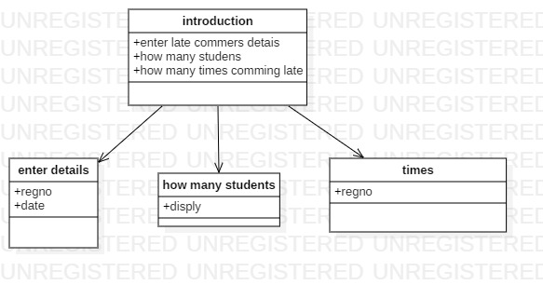

Class diagram

***3.3.2 USE CASE DIAGRAM:***

**A use case diagram in the Unified Modeling Language (UML) is a type of behavioral diagram defined by and created from a Use-case analysis. Its purpose is to present a graphical overview of the functionality provided by a system in terms of actors, their goals (represented as use cases), and any dependencies between those use cases. The main purpose of a use case diagram is to show what system functions are performed for which actor. Roles of the actors in the system can be depicted.**

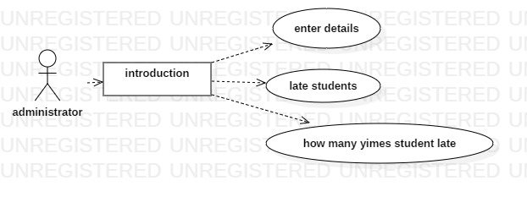

Use case diagram

**3.3.3 SEQUENCE DIAGRAM**

**A sequence diagram in Unified Modeling Language (UML) is a kind of interaction diagram that shows how processes operate with one another and in what order. It is a construct of a Message Sequence Chart. Sequence diagrams are sometimes called event diagrams, event scenarios, and timing diagrams.**

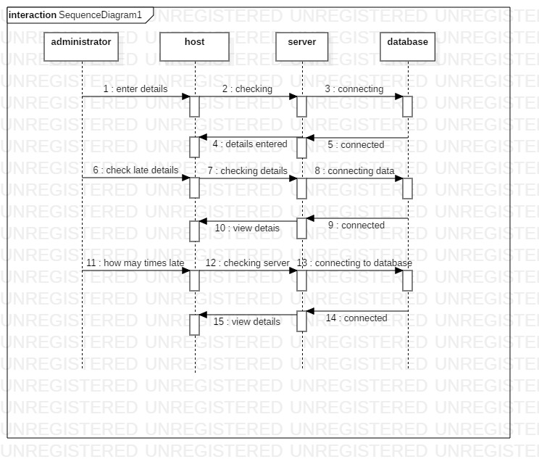

Sequence diagram

***3.3.4 ACTIVITY DIAGRAM:***

**Activity diagrams are graphical representations of workflow of step-wise activities and actions with support for choice, iteration and concurrency. In the Unified Modeling Language, activity diagrams are intended to model both computational and organizational processes (I. e, workflows), as well as the data flows intersecting with the related activities. Although activity diagrams primarily show the overall flow of control, they can also include elements showing the flow of data between activities through one or more data.**

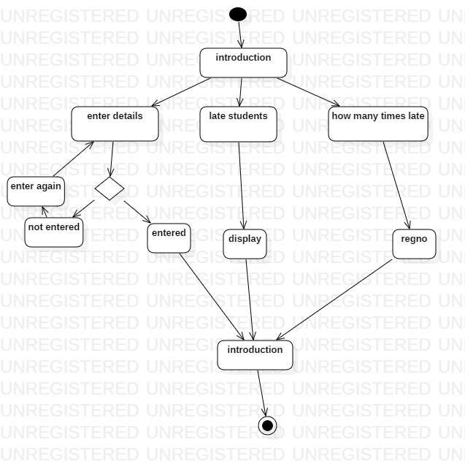

Activity diagram

***3.3.5 COLLABORATION DIAGRAM:***

**A collaboration diagram is a type of visual presentation that shows how various software objects interact with each other within an overall IT architecture and how users can benefit from this collaboration. A collaboration diagram often comes in the form of a visual chart that resembles a flow chart.**

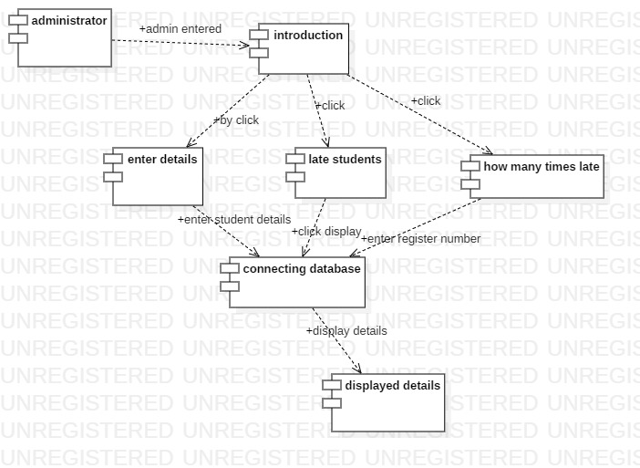

Collaboration diagram

**3.3.6 STATECHART DIAGRAM**

**The name of the diagram itself clarifies the purpose of the diagram andother details. it describes different states of the component n a system. The states are specifies to a component/object of a system.**

**A state chart diagram describes a state machine. State machine can be defined as a machine**

**which defines different states of an object and these states are controlled by external internal events.**

**State chart diagram is used to describe the different states of different objects in its life cyclic.Emphasis Is placed on the state changes upon some external or internal events. these objects are important to analysis and implement them accurately.**

**State chart diagrams are very important to describe the states . States can be identified as the condition of objects when a particular event occur.**

**Before the drawing a State chart diagram we should clarify the following components points-**

**1.Identify the important objects to be analyzed.**

**2.Identify the states.**

**3.Identify the elements.**

**Following is an example of a state chart diagram where the state of the order object is analyzed**

**The first state is an idle state from the where process starts. The next states are arrived for events like**

**Send request, confirm request, and dispatch order. These events are responsible for the state changes** **of order object.**

**During the life cycle of an object it goes through the following states and there may be abnormal exits . This abnormal exit may occur due to some problem in the system .When the entire life cycle is complete transaction as shown in the following figure. The initial and final state of an objectis also shown in the following figure.**

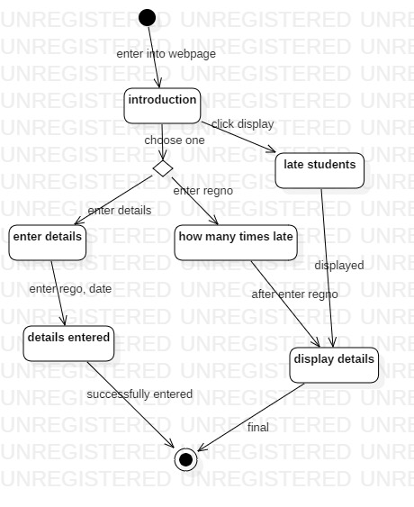

State chart diagram

***3.3.7 DEPLOYMENT DIAGRAM:***

**A deployment diagram in the Unified Modeling Language models the physical deployment of artifacts on nodes. To describe a web site, for example, a deployment diagram would show what hardware components ("nodes") exist (e. g., a web server, an application server, and a database server), what software components ("artifacts") run on each node (e. g., web application, database), and how the different pieces are connected (e. g. JDBC, REST, RMI).**

**The nodes appear as boxes, and the artifacts allocated to each node appear as rectangles within the boxes. Nodes may have sub nodes, which appear as nested boxes. A single node in a deployment diagram may conceptually represent multiple physical nodes, such as a cluster of database servers.**

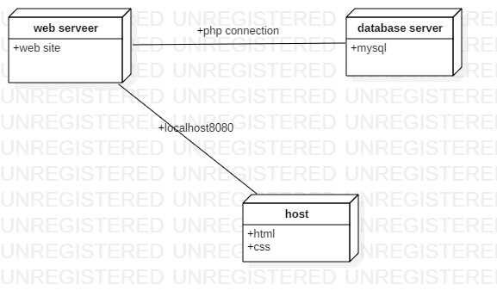

**Deployement diagram**

**Data flow diagrams illustrate how data is processed by a system in terms of inputs and outputs. Data flow diagrams can be used to provide a clear representation of any business function. The technique starts with an overall picture of the business and continues by analyzing each of the functional areas of interest. This analysis can be carried out in precisely the level of detail required. The technique exploits a method called top-down expansion to conduct the analysis in a targeted way.**

**As the name suggests, Data Flow Diagram (DFD) is an illustration that explicates the passage of information in a process. A DFD can be easily drawn using simple symbols. Additionally, complicated processes can be easily automated by creating DFD's using easy-to-use, free downloadable diagramming tools. A DFD is a model for constructing and analyzing information processes. DFD illustrates the flow of information in a process depending upon the inputs and outputs. A DFD can also be referred to as a Process Model. A DFD demonstrates business or technical process with the support of the outside data saved, plus the data flowing from the process to another and the end results.**

**Data flow diagram levels**

**Data flow diagrams are also categorized by level. Starting with the most basic, level 0, DFD get increasingly complex as the level increases. As you build your own data flow diagram, you will need to decide which level your diagram will be.**

**DATA FLOW DIAGRAM LEVEL 0:**

Enter details,

Late students display,

How many times late,

introduction

Late commers

Data Base

Selected Details

administrator

1.enter into introduction

2.enter data into

3.Accessing Data of

Selected data

4.Accessing details

**Level 0 DFD, also known as context diagrams, are the most basic data flow diagrams. They provide a broad view that is easily digestible but offers little detail. Level 0 data flow diagrams show a single process node and its connections to external entities.**

**3.3.8 DFD LEVEL 1**

**If no context diagram exists, first create one before attempting to construct the level 1 DFD (or construct the context diagram and level 1 DFD simultaneously).**

**The following steps are suggested to aid the construction of Level 1 DFD:**

1. **Identify processes. Each data-flow into the system must be received by a process. For each data-flow into the system examine the documentation about the system and talk to the users to establish a plausible process of the system that receives the data-flow.**
2. **Each process must have at least one output data-flow. Each output data-flow of the system must have been sent by a process; identify the processes that sends each system output.**
3. **Draw the data-flows between the external entities and processes.**
4. **Identify data stores by establishing where documents / data needs to be held within the system.**
5. **Add the data stores to the diagram, Labeling them with their local name or description.**
6. **Add data-flows flowing between processes and data stores within the system. Each data store must have at least one input data-flow and one output data-flow (otherwise data may be stored, and never used, or a store of data must have come from nowhere).**
7. **Ensure every data store has input and output data-flows to system processes. Most processes are normally associated with at least one data store.**
8. **Check diagram. Each process should have an input and an output. Each data store should have an input and an output. Check the system details.**
9. **so see if any process appears to be happening for no reason (i. e., some “trigger”data-flow is missing, that would make the process happen).**

administrator

introduction

Data Base

Enter student details

How many times late

Checking

checking details

Display data

On Browser

Late student

details

introductio

administrator

Enter

Website

Click

On

enter

saved Details

Saved Details

Late details

**Data flow diagram**

**CHAPTER - 4 IMPLEMENTATION**

1. IMPLEMENTATION OVERVIEW:
2. STEPS TO INSTALL XAMPP APACHEE SERVER.
3. ABOUT IDE FOR USING THIS PROJECT TO WRITE CODE.
4. *HOW TO RUN PHP CODE IN PHP XAMPP SERVER*

**4.1.1 IMPLEMENTATION OVERVIEW:**

**Implementation simply means carrying out the activities described in your work plan. Executing a project in the water and sanitation sector is a very complex mission, as it requires the coordination of a wide range of activities, the overseeing of a team, the management of budget, the communication to the public, among other issues. Independent of whether it is a social project to raise the awareness and promote hygiene or it is a construction project for service delivery, there is a certain process that has to be followed. The following lines will give you an introduction into the implementation of projects in sustainable sanitation and water management, and highlights key aspects that have to be taken into account for a successful implementation.**

**4.2.1 STEPS TO INSTALL XAMPP APACHEE SERVER:**

**In order to run a project code for this project we required a xampp server because in this project we use HYPER TEXT PRE-PROCCESOR language so,in order to run a PHP code we required one web server. In this we used web server as XAMPP .**

**4.2.2 XAMPP also it is a community web server in this we use APPACHE as a server and 'M' in XAMPP IS MYSQL for storing the database and also 'P' in XAMPP tells PHP and another 'p' tells it is a PERL .**

* + 1. **ADVANTAGES OF USING XAMPP APACHEE SERVER FOR THIS PROJECT:**

**1. It is totally free software to install in our host.**

**2. In XAMPP 'X' tells that ,this server can run in any 'OS'.**

**3. It has to be run on our computer whenever its required.**

* + 1. **STEPS TO DOWNLOAD XAMPP SERVER ON OUR COMPUTER:**

**Step:1 Open the XAMPP website. Go to** [**https://www.apachefriends.org/index.html**](https://www.apachefriends.org/index.html) **in computers web browser.**

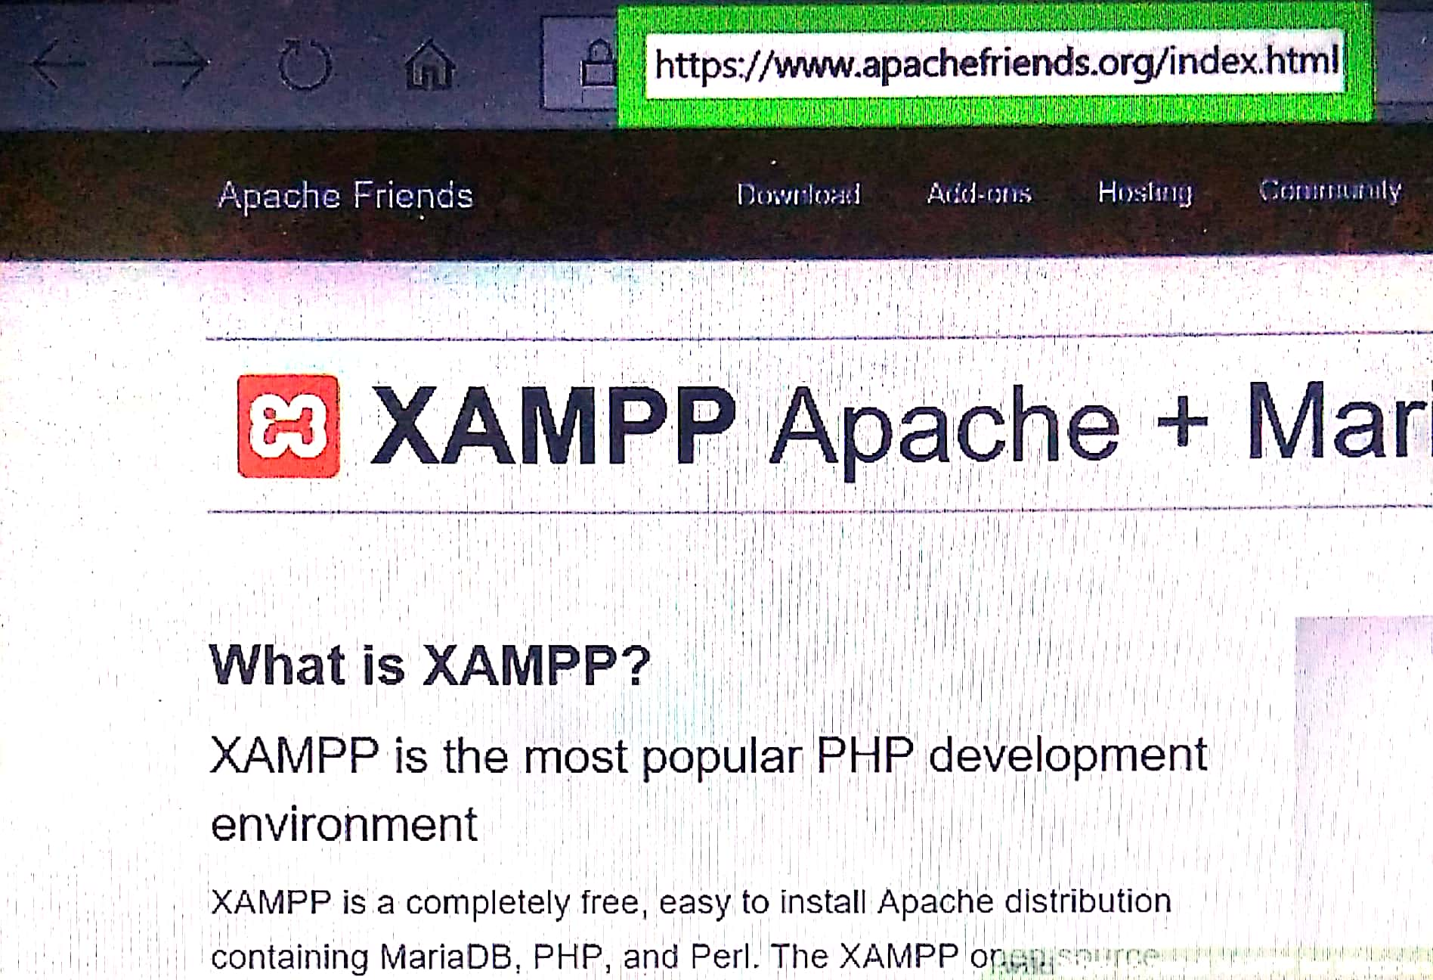

**step:2 Click on XAMPP FOR WINDOWS**

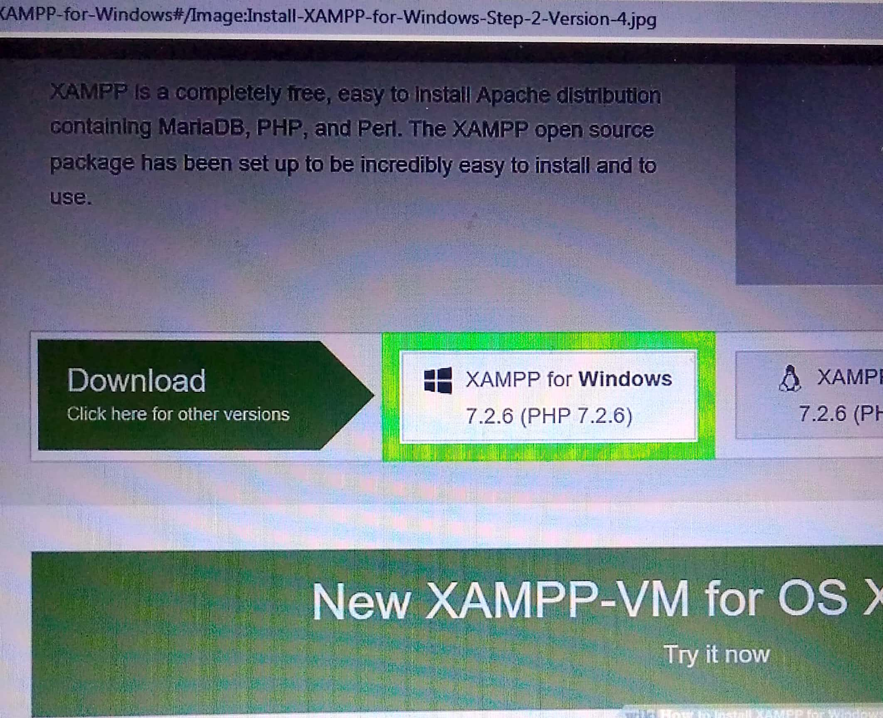 **step:3 Double click the downloaded file. This file should be named something like XAMPP -Win32.7.2-0vox installer, and you find default downloaded file.**

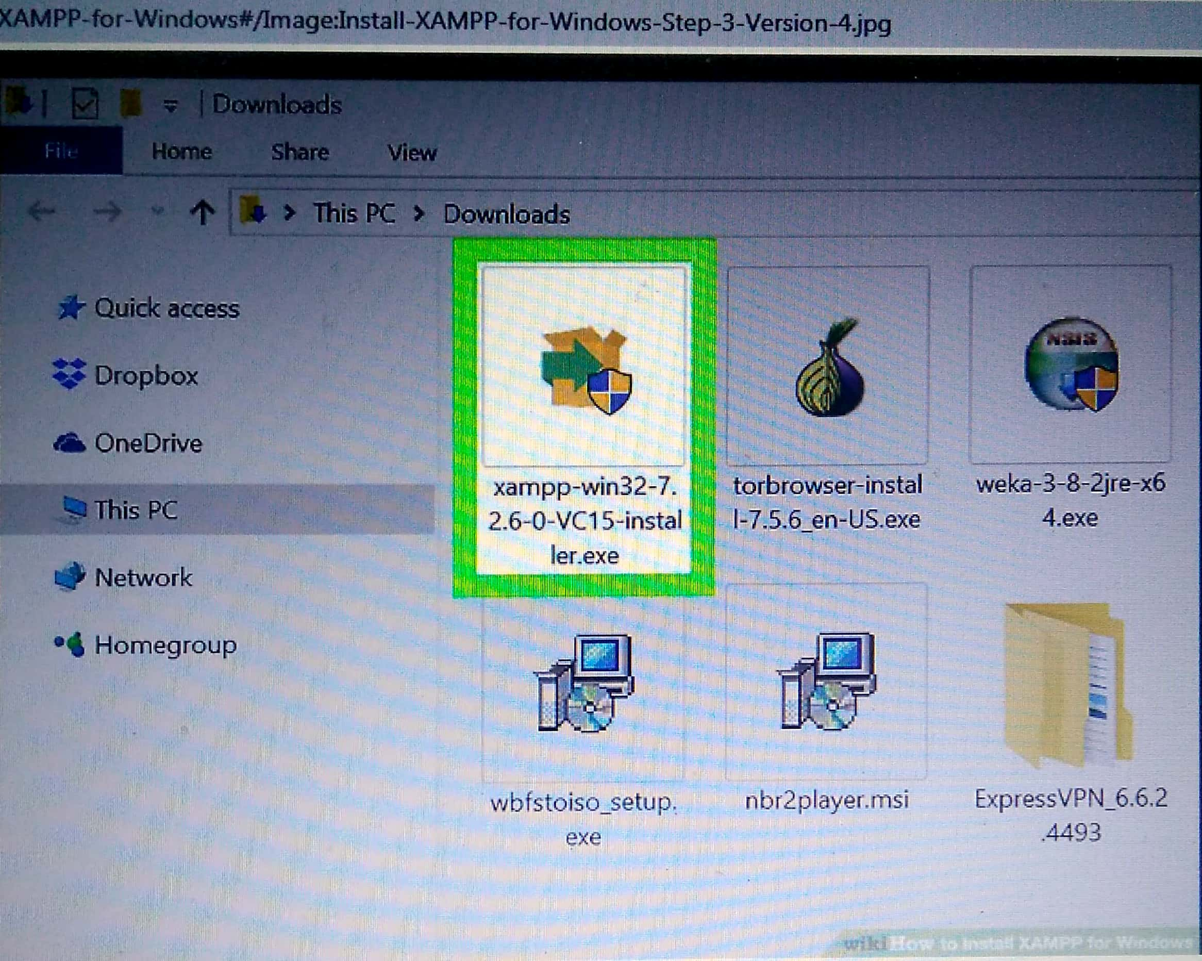 **step6: click YES button when prompted**

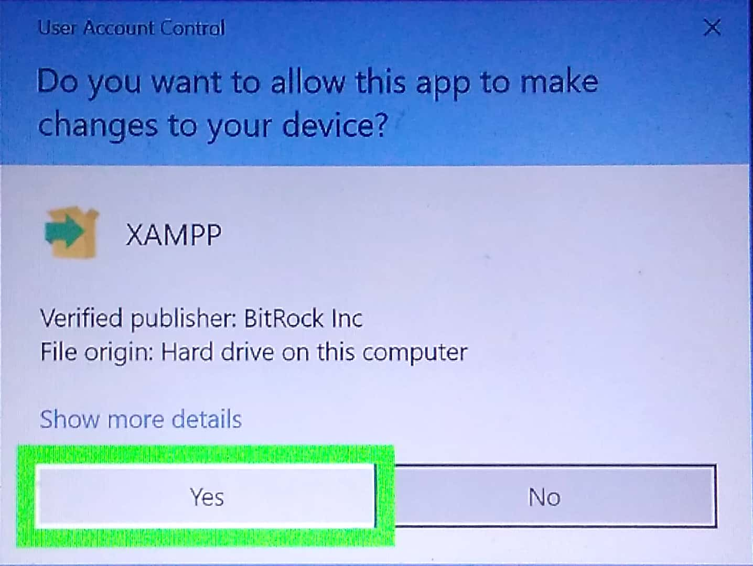

**step5: click next. Its at the bottom of the window**

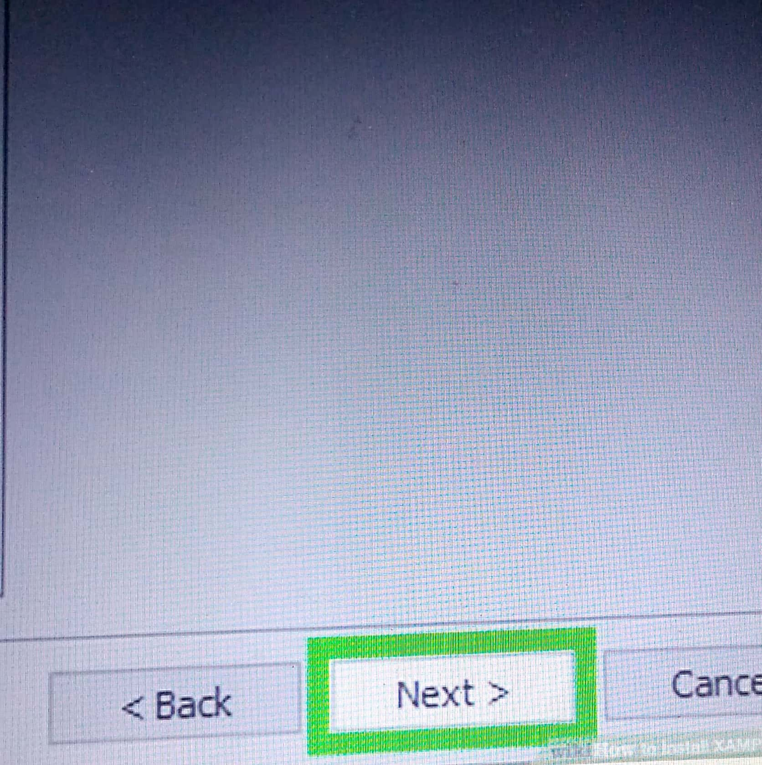

**step:6 Select aspects of XAMPP to install . Review the list of XAMPP attributes on the left side of the window you see an attribute that you don't want to install as port of XAMPP .**

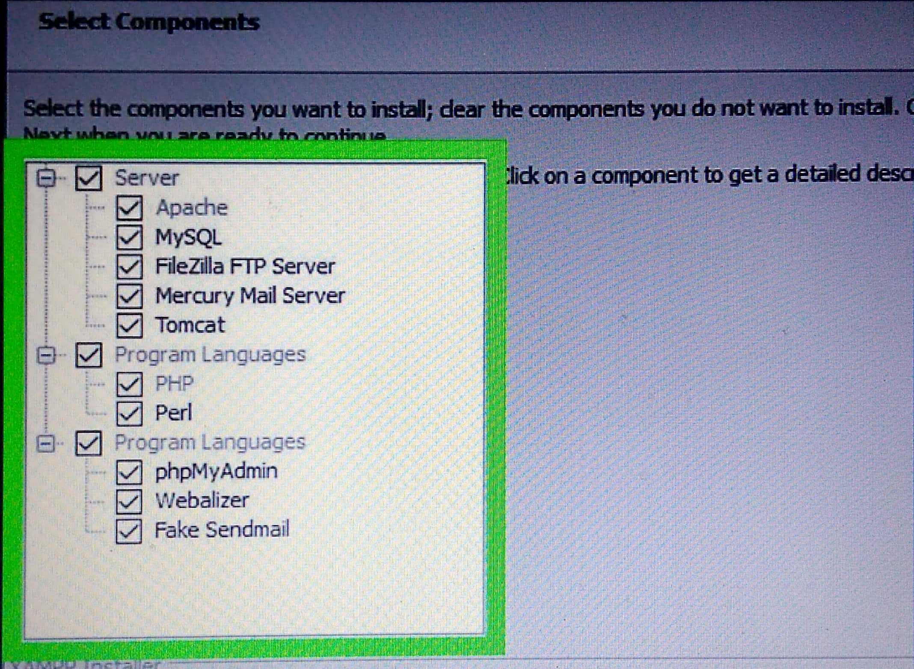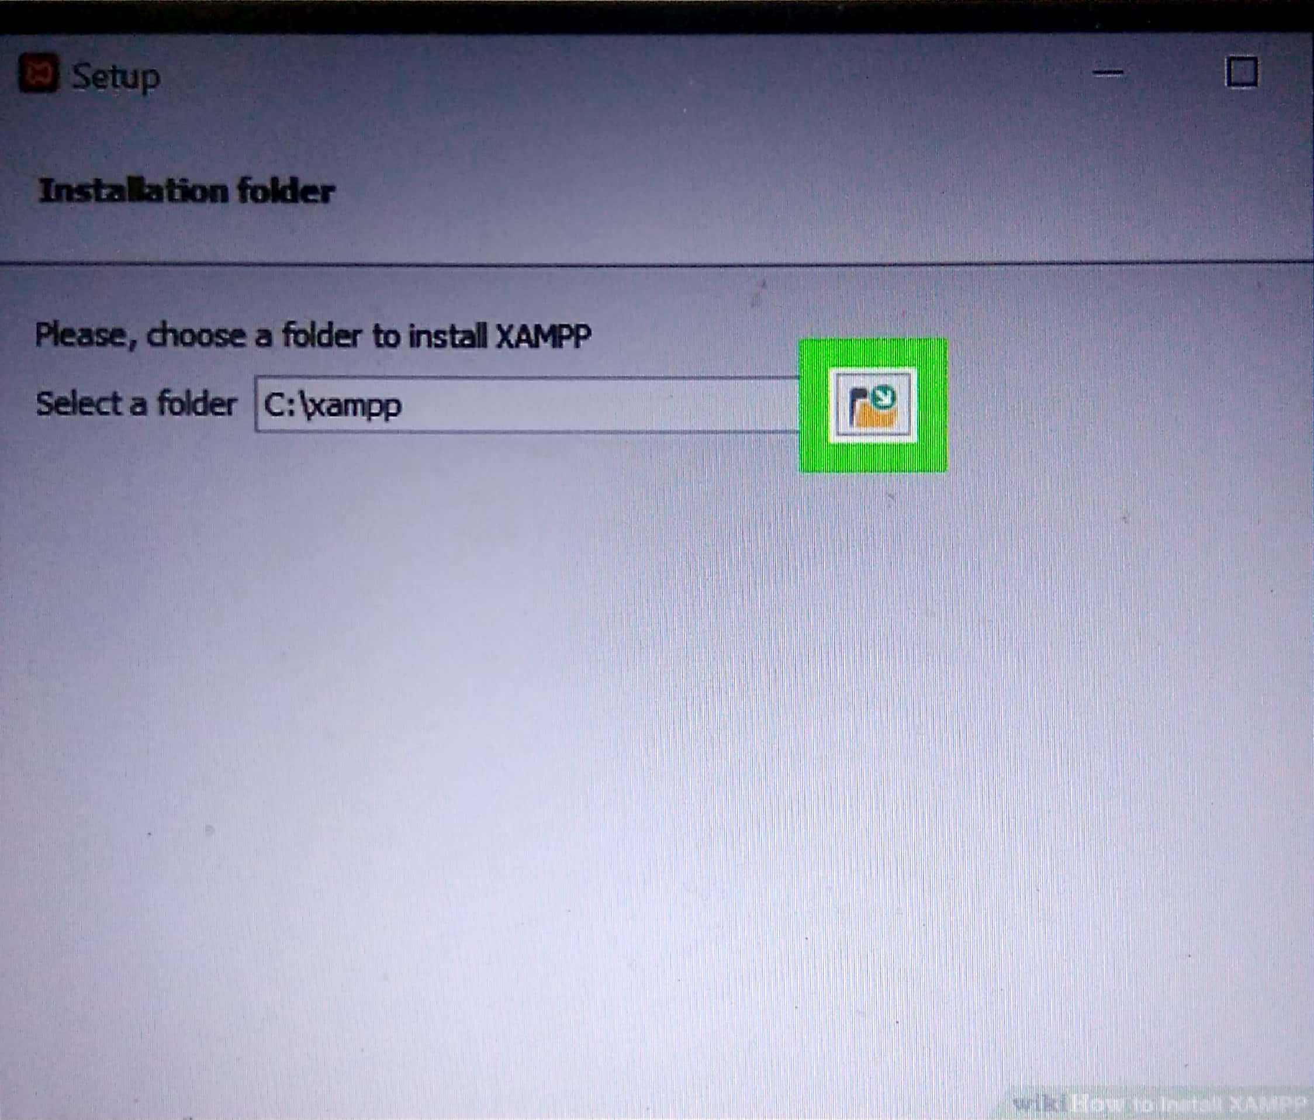 **Step: 7 click NEXT, it’s at the bottom of the window**

**Step:8 select an installation location, click the folder shaped icon to the right of the current installation destination, then click a folder on your computer**.

**Step:9 Click OK Doing so confirms your selected folder as your XAMPP installation location**

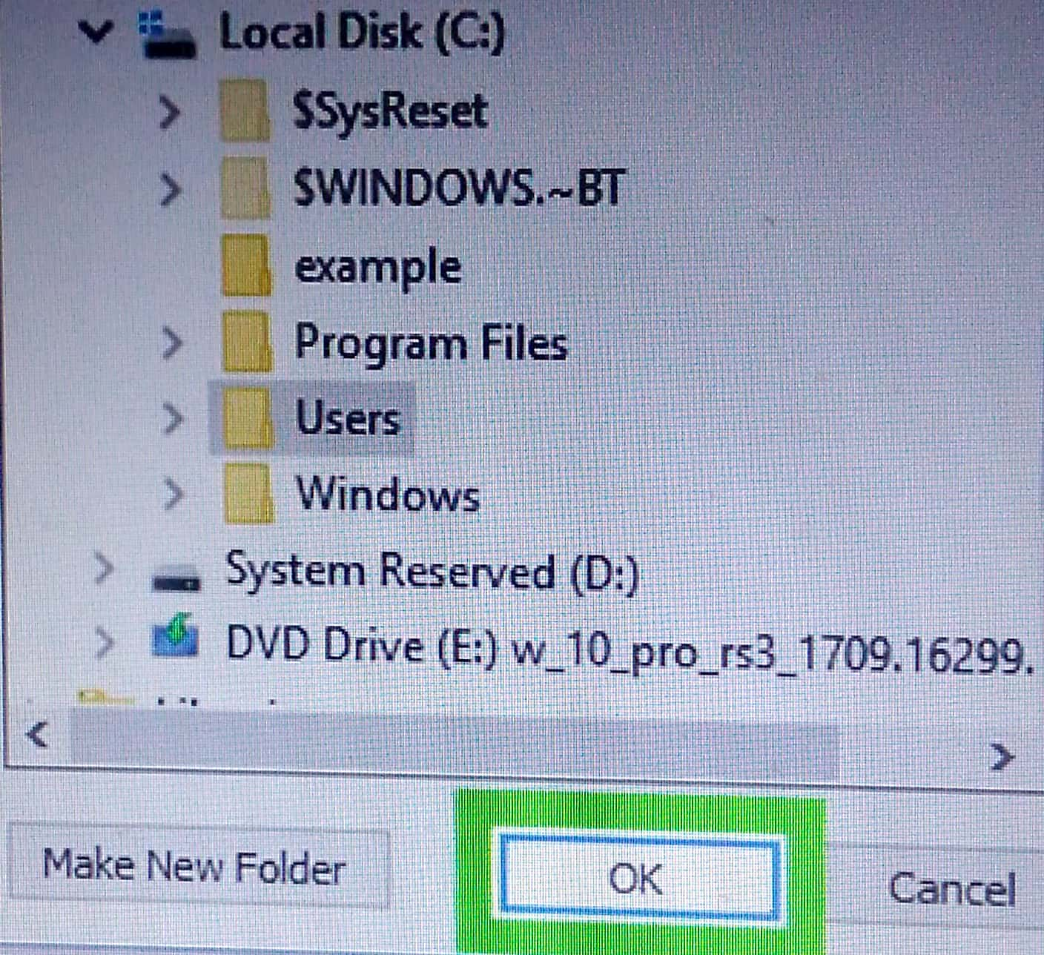

 **step:10 click NEXT. You'll find at the bottom of the page**

**Step:11 UCheck the “Learn more bottom” box,then click NEXT .”The learn more about the Bitnami” box is in the middle of the page.**

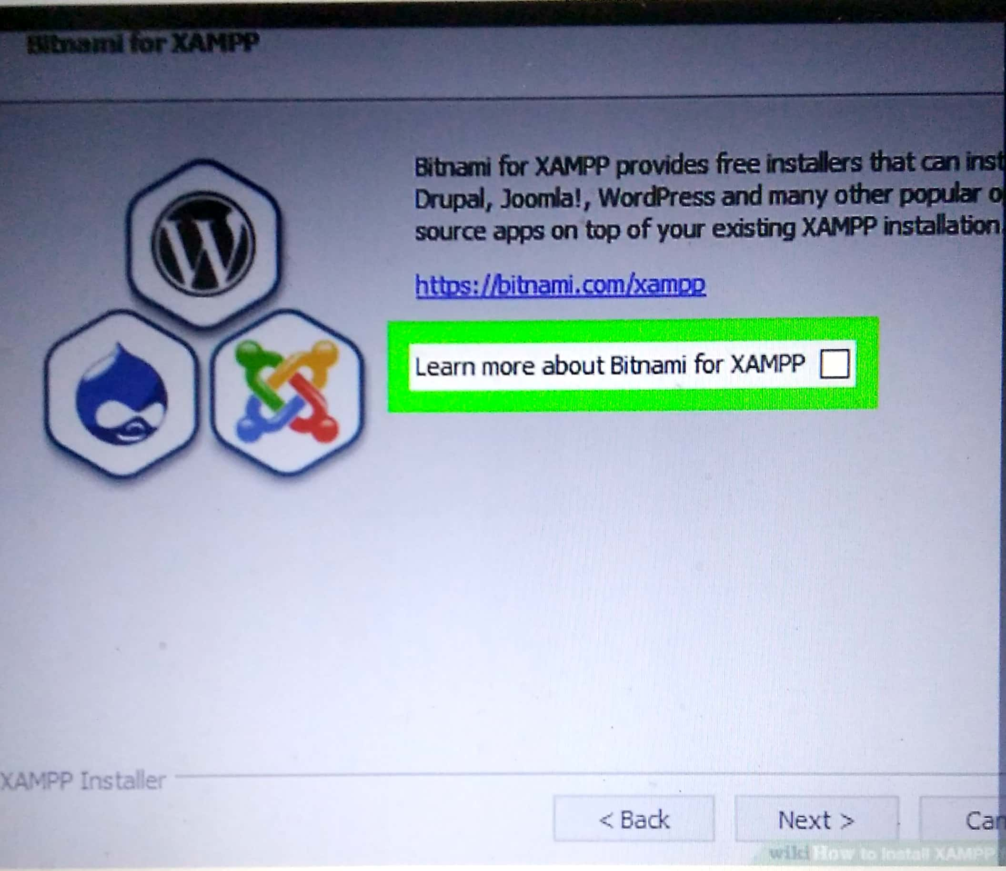

**Step:12 Begin installation XAMPP, click next at the bottom of the window to do so XAMPP will begin installing its files at the middle of the page.**

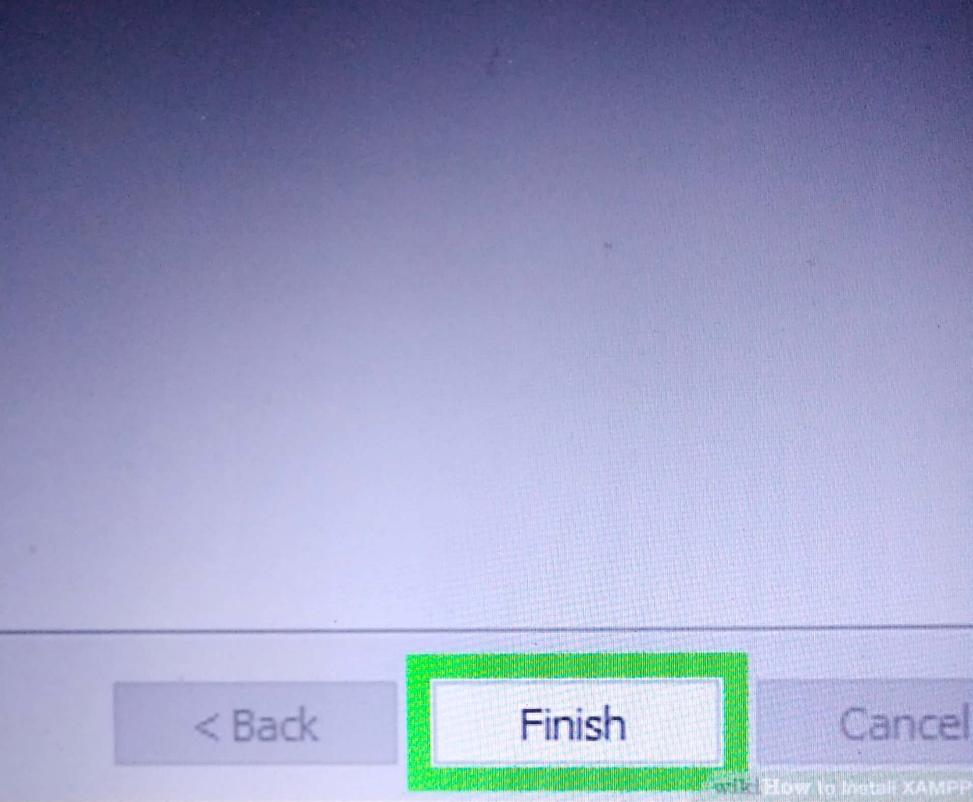

**Step:13 click FINISH and after select your language.**

**Step:14 Run XAMPP as an administator on desktop**

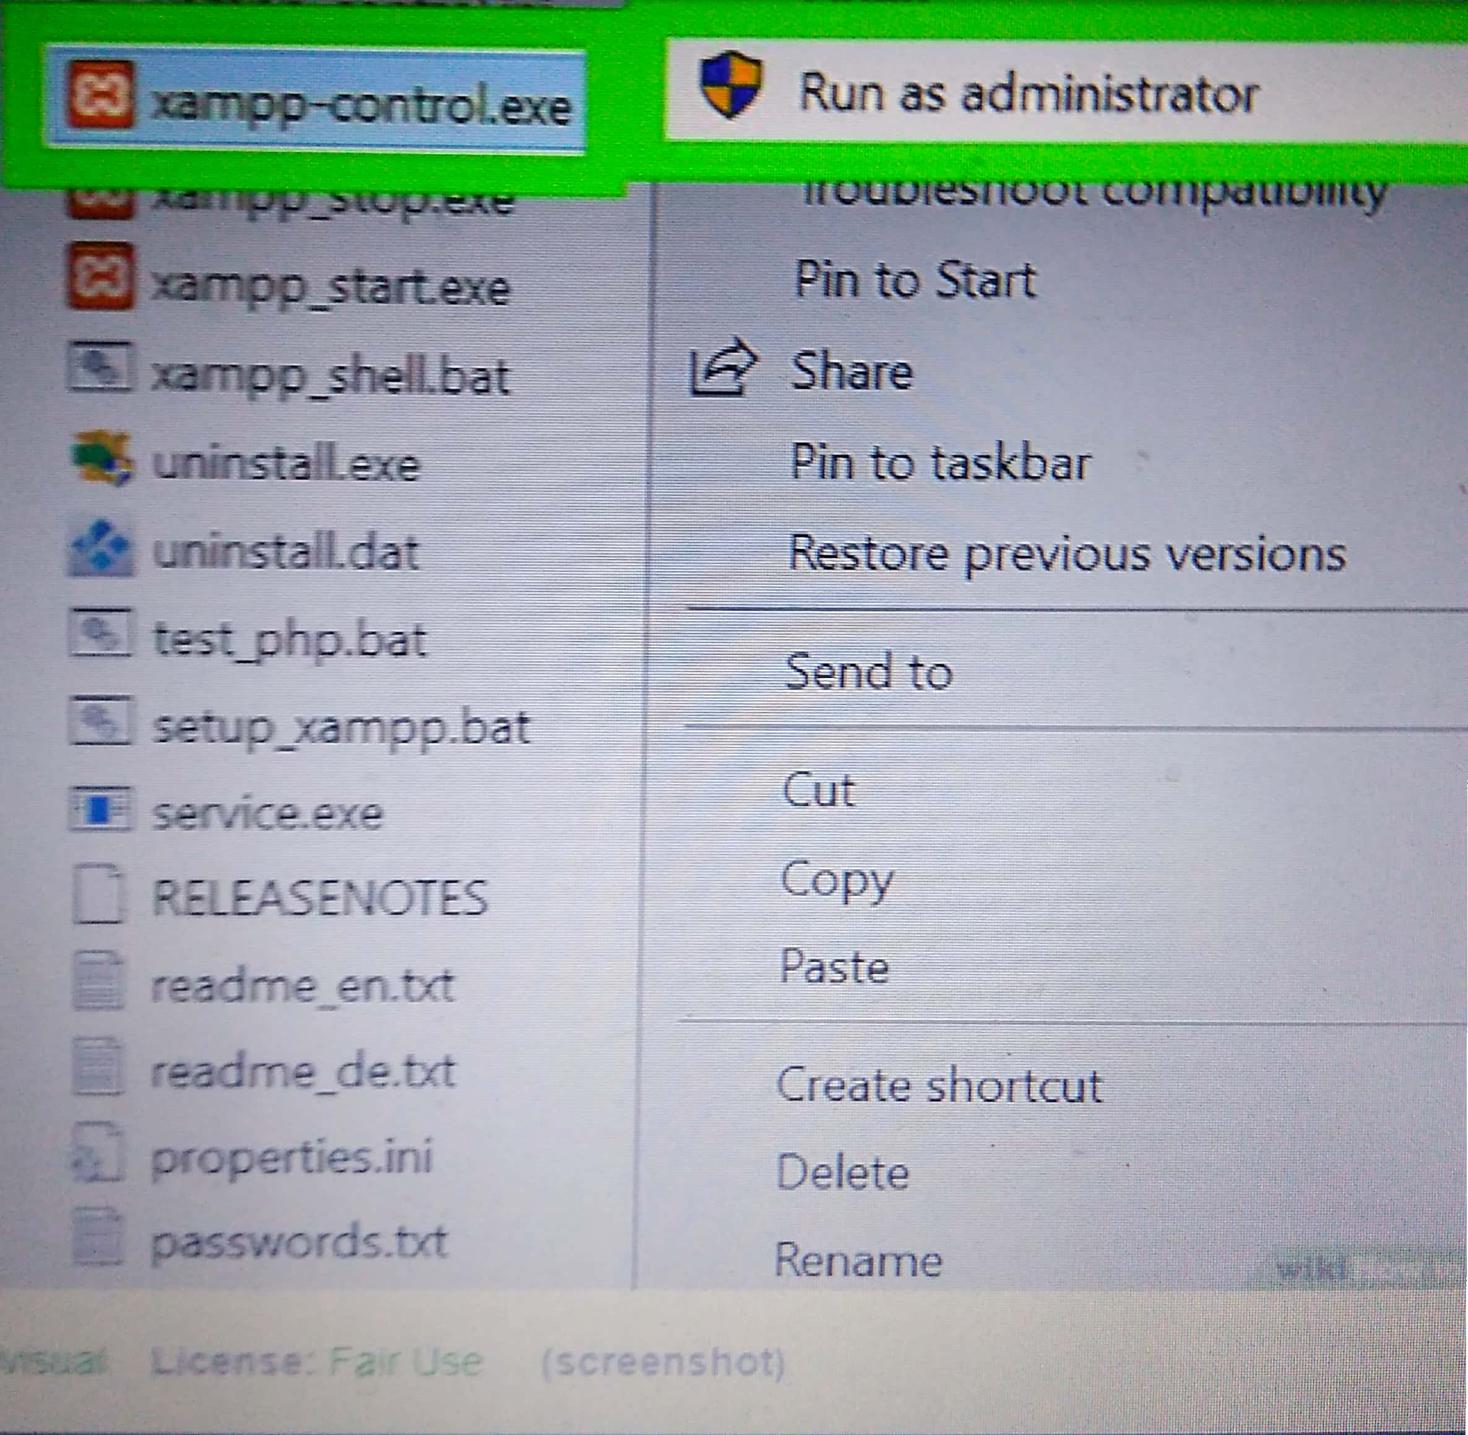

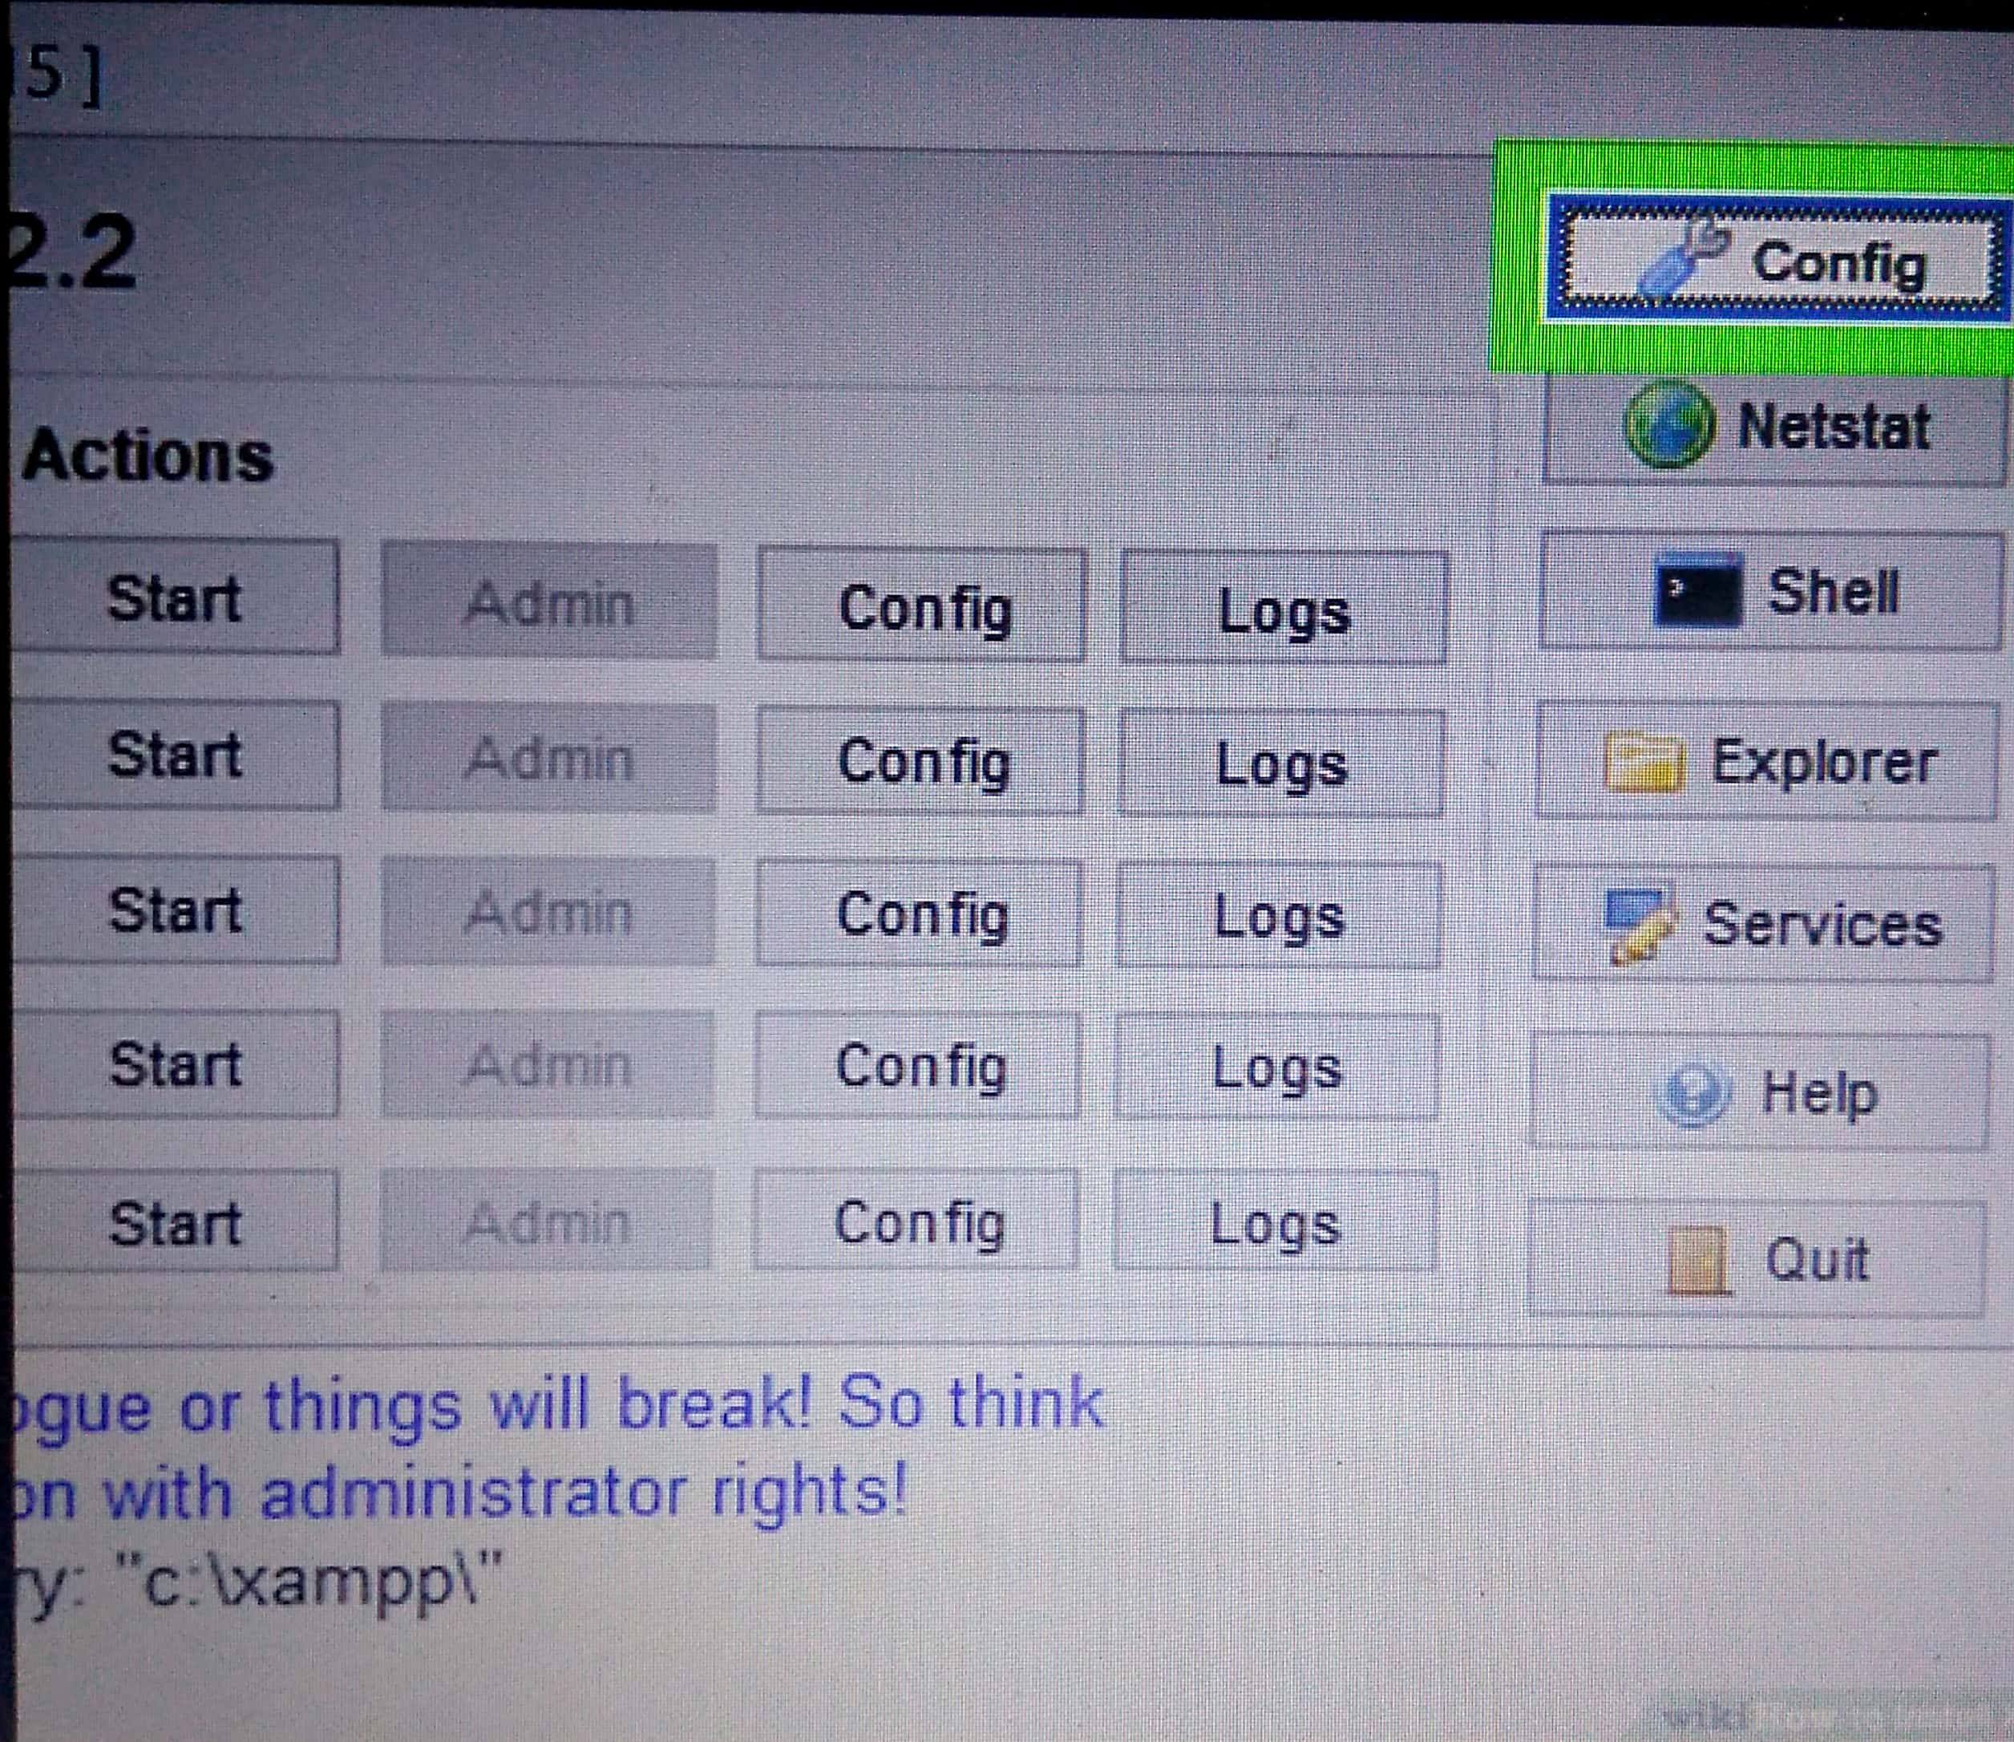 **Step:15 Finally configure the port numbers and run the XAMPP In system.**

**4.3.1:ABOUT ATOM IDENTIFIED**

**Atom is based on Electron (formerly known as Atom Shell), a framework that enables cross-platform desktop applications using Chromium and Node.js. It is written in Coffee Script and Less. It was able to be used as an integrated development environment (IDE) .**

**4.3.2:USAGE OF ATOM IDE TO MY PROJECT:**

**1. Quick Open**

Nuclide goes beyond just normal file opening capabilities. Quick Open provides multiple mechanisms to find a file, from recently opened files to a global Omni -Search that lets you search for anything a file might contain.

* [Toggling](https://nuclide.io/docs/features/quick-open/" \l "toggling)

* [OmniSearch](https://nuclide.io/docs/features/quick-open/" \l "omnisearch)

* [Filenames](https://nuclide.io/docs/features/quick-open/" \l "filenames)

* [Open Files](https://nuclide.io/docs/features/quick-open/" \l "open-files)

* [Recent Files](https://nuclide.io/docs/features/quick-open/" \l "recent-files)

* [Hack Symbols](https://nuclide.io/docs/features/quick-open/" \l "hack-symbols)
* [Code Search](https://nuclide.io/docs/features/quick-open/#code-search)

**2. Debugger**

One of the key features of Nuclide is its multiple-language debugging support provided with a debugger interface inspired by the familiar [Chrome DevTools](https://developer.chrome.com/devtools). The Nuclide Debugger provides many capabilities allowing you to have a productive debug loop, including inspection, watches, setting breakpoints, step in/over/out, etc.

* [Instantiation](https://nuclide.io/docs/features/debugger/#instantiation)

* [Basics](https://nuclide.io/docs/features/debugger/" \l "basics)

* + [Debuggable Target](https://nuclide.io/docs/features/debugger/" \l "debuggable-target)

* + [Breakpoints](https://nuclide.io/docs/features/debugger/" \l "breakpoints)

* + [Debugger](https://nuclide.io/docs/features/debugger/" \l "debugger)

* + [Stepping](https://nuclide.io/docs/features/debugger/" \l "stepping)

* + [Evaluation](https://nuclide.io/docs/features/debugger/" \l "evaluation)

* [Language Specific Debuggin](https://nuclide.io/docs/features/debugger/" \l "language-specific-debugging)
* [Platform Specific Debugging](https://nuclide.io/docs/features/debugger/#platform-specific-debugging)

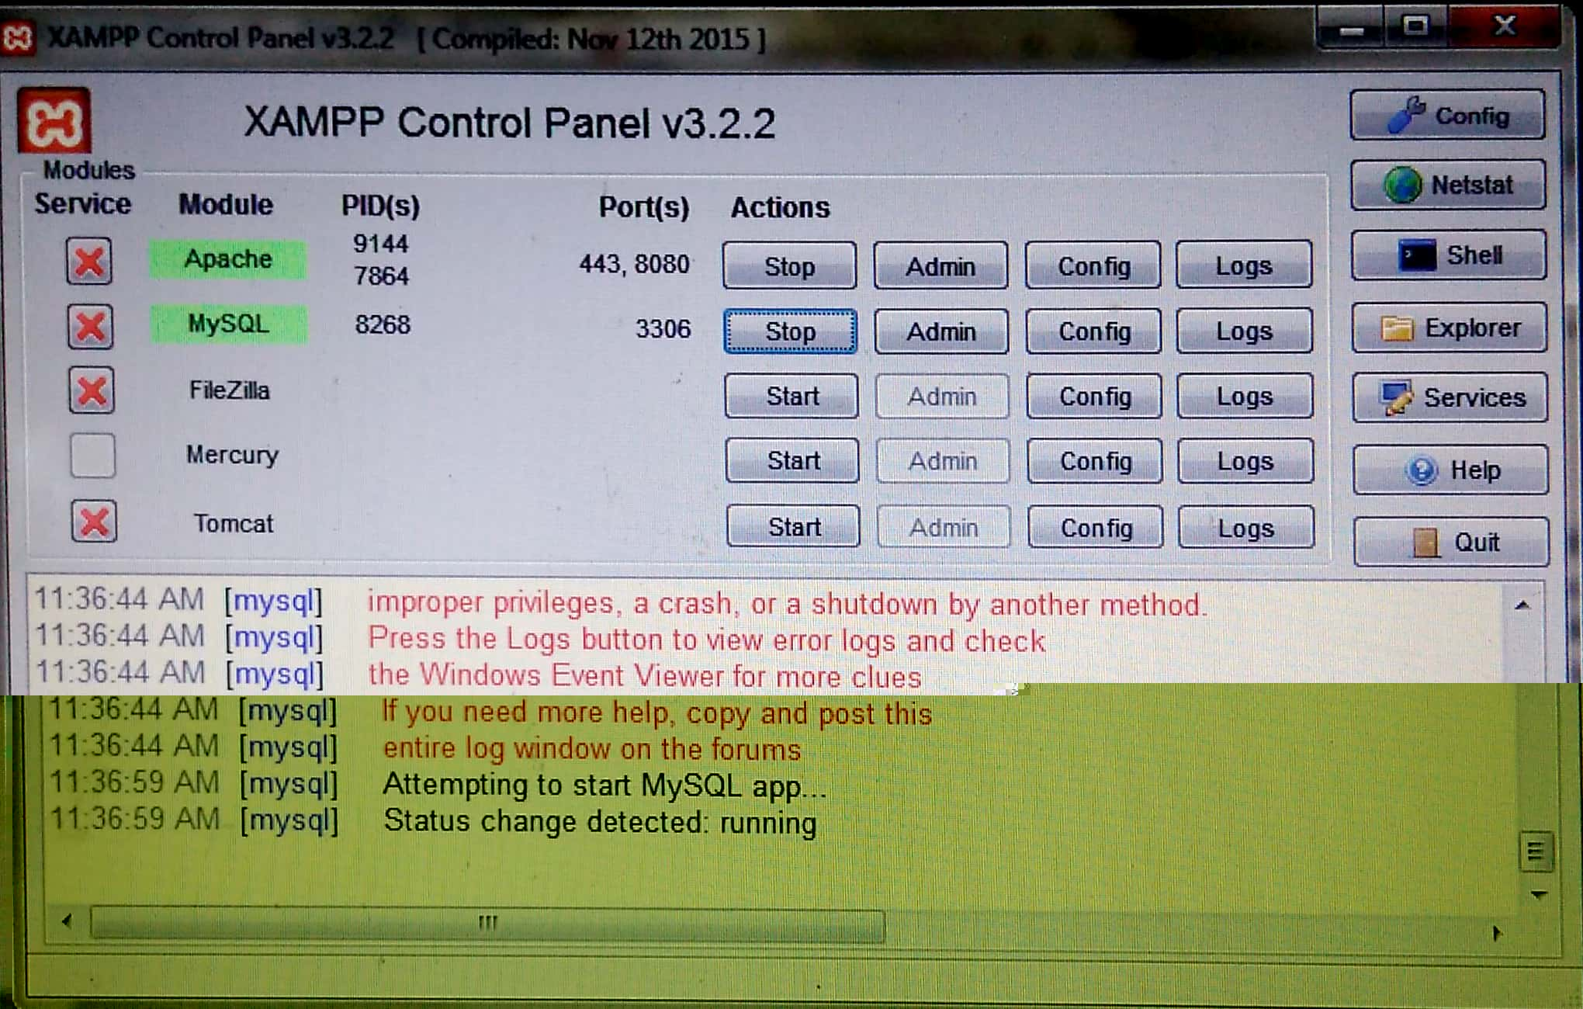**3. It is very use -full to this project to do correctly and also by using this ATOM IDE the source code can be debugged easily before run the program and also it showing a basic syntax on on display so it makes easy to remember the code and also parallel moving to another files without go back so, it makes time gain . This gives many tools to make an applications on source code.**

**4.4.1 Steps to run PHP code to run the source code of this project:**

**Step.1: In first step, we have to turn the XAMPP server on then only our programs can execute.**

**Step.2: Then write source code in ATOM IDE and save file name with .PHP with in your sub folder of a folder htdocs in xampp folder.**

**Step.3: Then open a web browser chrome and the URL full path then click enter and now result can be identified on your browser.**

**Step.4:If you have to make any changes then go back to your IDE and change the code and again run your source code in web browser with give again full URL path.**

**CHAPTER 5**

**TESTING**

**5.1 INTRODUCTION**

**Software testing is an investigation conducted to provide stakeholders with information about the quality of the software product or service under test. Software testing can also provide an objective, independent view of the software to allow the business to appreciate and understand the risks of software implementation. Test techniques include the process of executing a program or application with the intent of finding software bugs (errors or other defects), and verifying that the software product is fit for use.**

**Software testing involves the execution of a software component or system component to evaluate one or more properties of interest. In general, these properties indicate the extent to which the component or system under test**

* **meets the requirements that guided its design and development,**
* **responds correctly to all kinds of inputs,**
* **performs its functions within an acceptable time,**
* **is sufficiently usable,**
* **can be installed and run in its intended environments, and**
* **Achieves the general result its stakeholder’s desire.**

**As the number of possible tests for even simple software components is practically infinite, all software testing uses some strategy to select tests that are feasible for the available time and resources. As a result, software testing typically (but not exclusively) attempts to execute a program or application with the intent of finding software bugs (errors or other defects). The job of testing is an iterative process as when one bug is fixed; it can illuminate other, deeper bugs, or can even create new ones.**

**Software testing can provide objective, independent information about the quality of software and risk of its failure to users or sponsors.**

**Software testing can be conducted as soon as executable software (even if partially complete) exists. The overall approach to software development often determines when and how testing is conducted. For example, in a phased process, most testing occurs after system requirements have been defined and then implemented in testable programs. In contrast, under an agile approach, requirements, programming, and testing are often done concurrently.**

**5.2 SOFTWARE TESTING TECHNIQUES**

**Software testing is a critical element software quality assurance and represents the ultimate review of specification, designing and coding. A software testing method in which the internal structure/design/implementation of the item being tested is not known to the tester. These tests can be functional or non-functional, though usually functional.**

***5.2.1 Test case design :***

**Any under graduation/graduation product can be tested in one of two ways**

***5.2.1.1 White Box Testing :***

**White-box testing is a method of testing software that tests internal structures or workings of an application, as opposed to its functionality. In white-box testing an internal perspective of the system, as well as programming skills, are used to design test cases. The tester chooses inputs to exercise paths through the code and determine the expected outputs. White Box Tesitng is also called as Glass Box testing.**

* Flow Graph Notation
* Cyclomatic Complexity
* Deriving Test Cases
* Graph Matrices
* Control Structure Testing
* Condition Testing
* Data Flow Testing
* Loop Testing

***5.2.1.2 Black Box Testing :***

**Basically software under test is called as “Black-Box”, we are treating this as black box & without checking internal structure of software we test the software. All testing is done as customer’s point of view and tester is only aware of what is software is suppose to do but how these requests are processing by software is not aware.**

* **The main purpose of the Black Box is to check whether the software is working as per expected in requirement document & whether it is meeting the user expectations or not.**
* **The steps involved in the black box testing case design are**
* **Graph Based testing methods**
* **Equivalence portioning**
* **Boundary value**

**Source codes using php html and css used in this project**

* 1. **code for developing the website on introduction**

**<html>**

**<head>**

**<TITLE>INTRODUCTION</TITLE>**

**</head>**

**<body bgcolor="#E6FAFA">**

**<div class="container">**

**<div class="row">**

**<CENTER><h1>ANDHRA LOYOLA COLLEGE</H1>**

**<h3>(AUTONOMOUS)</h3>**

**<h2>'A COLLEGE WITH POTENTIAL FOR EXCELLENCE'</h2>**

**<h5>Re-accredited with 3.66/4.00 at A+ grade by NAAC</h5>**

**<hr/ size="3"><br/><br/><br/><br/><br/><br/>**

**<form name="form-control" action="form0get_response.php">**

**<button type="LATE" class="btn btn-primary" name="late" value="late" id="submit_form">ENTER LATE COMMERS DETAILS</button>**

**</form>**

**<form name="form-control" action="form3particular.php">**

**<button type="TIMES" class="btn btn-primary" name="times" value="times" id="submit_form">HOW MANY TIMES STUDENT COME LATE</button>**

**</form>**

**<form name="form-control" action="form4display.php">**

**<button type="DISPLAY" class="btn btn-primary" name="display" value="disply" id="submit_form">DISPLAY MORE THAN 3 TIMES</button>**

**</form></center>**

**<div class="response_msg"></div>**

**</div>**

**</div>**

**</body>**

**</html>**

* 1. **code for implementing the form website form to store the data into database**

**<html>**

**<head>**

**<TITLE> STUDENT DETAILS</TITLE>**

**</head>**

**<body bgcolor="#E6E6FA">**

**<div class="container">**

**<div class="row">**

**<div class="col-md-8">**

**<center><h1 STYLE="COLOR:#00ff00">ENTER LATE COMMERS STUDENTS DETAILS</h1><hr><br/><br/><br/><br/><br/><br/><br/><br/>**

**<h3>enter student details</h3>**

**<form name="form-control" action="get_response.php" method="post">**

**<div class="form-group">**

**<label for="RegNo">RegNo</label>**

**<input type="integer" class="form-control" name="rollno" placeholder="Register Number" required>**

**</div><br/>**

**<div class="form-group">**

**<label for="Date">Date</label>**

**<input type="date" class="form-control" name="date" placeholder="Date" required>**

**</div><br/>**

**<button type="submit" class="btn btn-primary" name="submit" value="Submit" id="submit_form">Submit</button>**

**<button type="reset" class="btn btn-primary" name="reset" value="reset" id="submit_form">Reset</button>**

**</form></center>**

**<div class="response_msg"></div>**

**</div>**

**</div>**

**</div>**

**</body>**

**</html>**

* 1. **connecting the form data store into database**

**<?php**

**$host = "localhost";**

**$userName = "root";**

**$password = "";**

**$dbName = "latecommers";**

**// Create database connection**

**$conn = new mysqli($host, $userName, $password, $dbName);**

**// Check connection**

**if ($conn->connect_error) {**

**die("Connection failed: " . $conn->connect_error);**

**}**

**else**

**{**

**echo 'database connected successfully<br/>';**

**}**

**?>**

**Above connection program save it as config.php**

**<?php**

**require_once("config.php");**

**if((isset($_POST['rollno'])&& $_POST['rollno'] !='') && (isset($_POST['date'])&& $_POST['date'] !=''))**

**{**

**$reg_no = $conn->real_escape_string($_POST['rollno']);**

**$date = $conn->real_escape_string($_POST['date']);**

**echo 'roll no=',$reg_no,'<br>';**

**echo 'date=',$date,'<br>';**

**$sql = " INSERT INTO late (regno, date) VALUES ('$reg_no', '$date')";**

**if($sql == $conn->query($sql)){**

**die('There was an error running the query [' . $conn->error . ']');**

**}**

**else**

**{**

**echo "Thank you! Inserted successfully";**

**}**

**}**

**else**

**{**

**echo "Please fill RollNo and Date";**

**}**

**header("refresh:1; url:form0get_response.php");**

**?>**

* 1. **code for display the data from the database to display how many times student coming late.**

**<html>**

**<head>**

**<TITLE>HOW MANY TIMES STUDENT COME LATE</TITLE>**

**</head>**

**<body bgcolor="#DEB787">**

**<div class="container">**

**<div class="row">**

**<div class="col-md-8">**

**<center><h1 STYLE="COLOR:#BLACK">ENTER REGISTER NUMBER </h1>**

**<h2>how many times particular student come late</h2><hr><br/><br/><br/><br/><br/><br/><br/><br/>**

**<h3>enter student details</h3>**

**<form name="form-control" action="particulano.php" method="post">**

**<div class="form-group">**

**<label for="RegNo">RegNo</label>**

**<input type="integer" class="form-control" name="rollno" placeholder="Register Number" required>**

**</div><br/>**

**<button type="submit" class="btn btn-primary" name="submit" value="Submit" id="submit_form">Submit</button>**

**<button type="reset" class="btn btn-primary" name="reset" value="reset" id="submit_form">Reset</button>**

**</form></center>**

**<div class="response_msg"></div>**

**</div>**

**</div>**

**</div>**

**</body>**

**</html>**

**Code for the above form data is connected to the database to retrieve data**

**<?php**

**$servername = "localhost";**

**$username = "root";**

**$password = "";**

**$dbname = "latecommers";**

**// Create connection**

**$conn = new mysqli($servername, $username, $password, $dbname);**

**// Check connection**

**if ($conn->connect_error) {**

**die("Connection failed: " . $conn->connect_error);**

**}**

**$reg_no = $conn->real_escape_string($_POST['rollno']);**

**$sql = "SELECT * FROM late WHERE regno=$reg_no";**

**$result = $conn->query($sql);**

**if ($result->num_rows > 0) {**

**echo "<table border=1><tr><th>regno</th><th>date</th></tr>";**

**// output data of each row**

**while($row = $result->fetch_assoc()) {**

**echo "<tr><td>".$row["regno"]."</td><td>".$row["date"]."</td></tr>";**

**}**

**echo "</table>";**

**} else {**

**echo "0 results";**

**}**

**$conn->close();**

**?>**

* 1. **code for accessing the data form database how many students are coming late.**

**<html>**

**<Head>**

**<TITLE>HOW MANY TIMES STUDENT COME LATE</TITLE>**

**</head>**

**<body bgcolor="#DEB887">**

**<div class="container">**

**<div class="row">**

**<CENTER><h1>ANDHRA LOYOLA COLLEGE</H1>**

**<h3>(AUTONOMOUS)</h3>**

**<hr/><br/><br/><br/><br/><br/><br/>**

**<form name="form-control" action="display.php" method="post">**

**<p>By clicking the display button to know how many students are comming late more than 3 times</p>**

**<button type="display" class="btn btn-primary" name="display" value="Display" id="submit_form">Display</button>**

**</form></center>**

**<div class="response_msg"></div>**

**</div>**

**</div>**

**</body>**

**</html>**

**Code for accessing the data from the database to display student details.**

**<?php**

**$servername = "localhost";**

**$username = "root";**

**$password = "";**

**$dbname = "latecommers";**

**// Create connection**

**$conn = new mysqli($servername, $username, $password, $dbname);**

**// Check connection**

**if ($conn->connect_error) {**

**die("Connection failed: " . $conn->connect_error);**

**}**

**$sql = "SELECT regno,count(*) FROM late group by regno having count(*)>=3";**

**$result = $conn->query($sql);**

**if ($result->num_rows > 0) {**

**echo "<table border=1><tr><th>regno</th><th>count(regno)</th></tr>";**

**// output data of each row**

**while($row = $result->fetch_assoc()) {**

**echo "<tr><td>".$row["regno"]."</td><td>".$row["count(*)"]."</td></tr>";**

**}**

**echo "</table>";**

**} else {**

**echo "0 results";**

**}**

**$conn->close();**

**?>**

**Screen shots on project execution:**

* + 1. **open the xampp server and start the apache and mysql server**

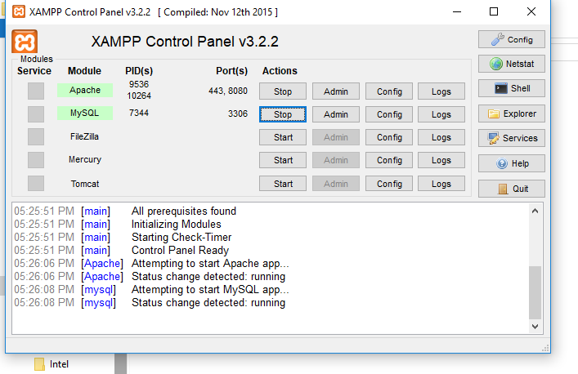

* + 1. **Next open the google chrome and the type localhost:8080//project/introduction.php**

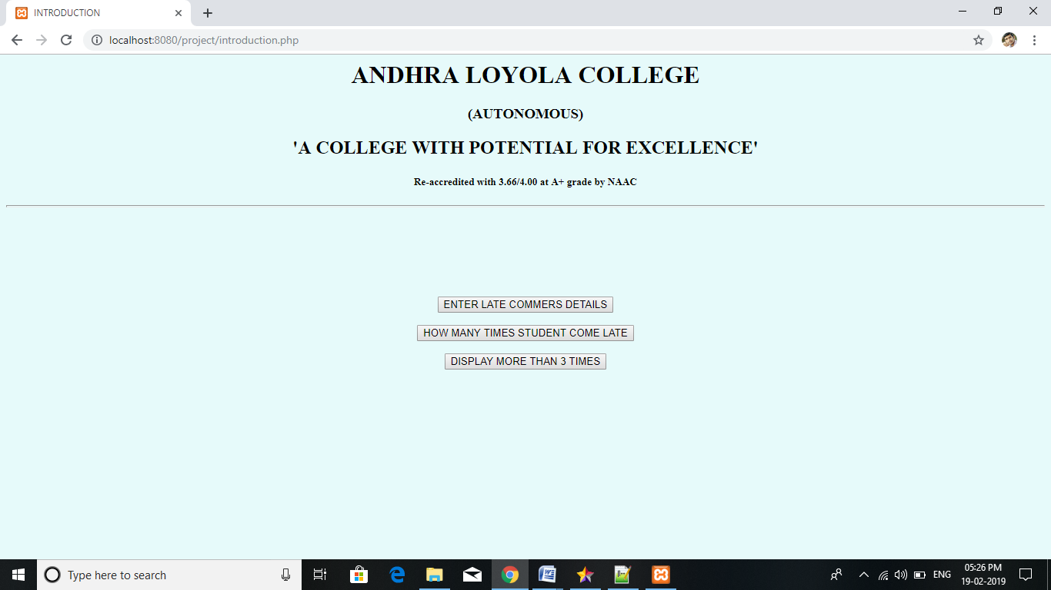

* + 1. **Next click the ENTER LATE COMMERS DETAILS button, then fill the following form**

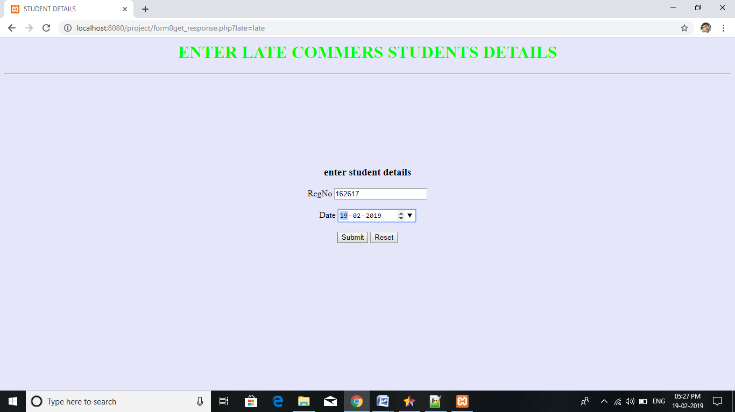

* + 1. **After submitting the form details that data is stored into the database, then following output will displayed.**

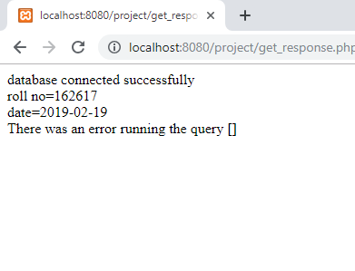

**5.after inserting the data go to the introduction form then click HOW MANY TIMES STUDENT COME LATE**



* 1. **After clicking the button one form will be displayed , then enter the register number and submit**

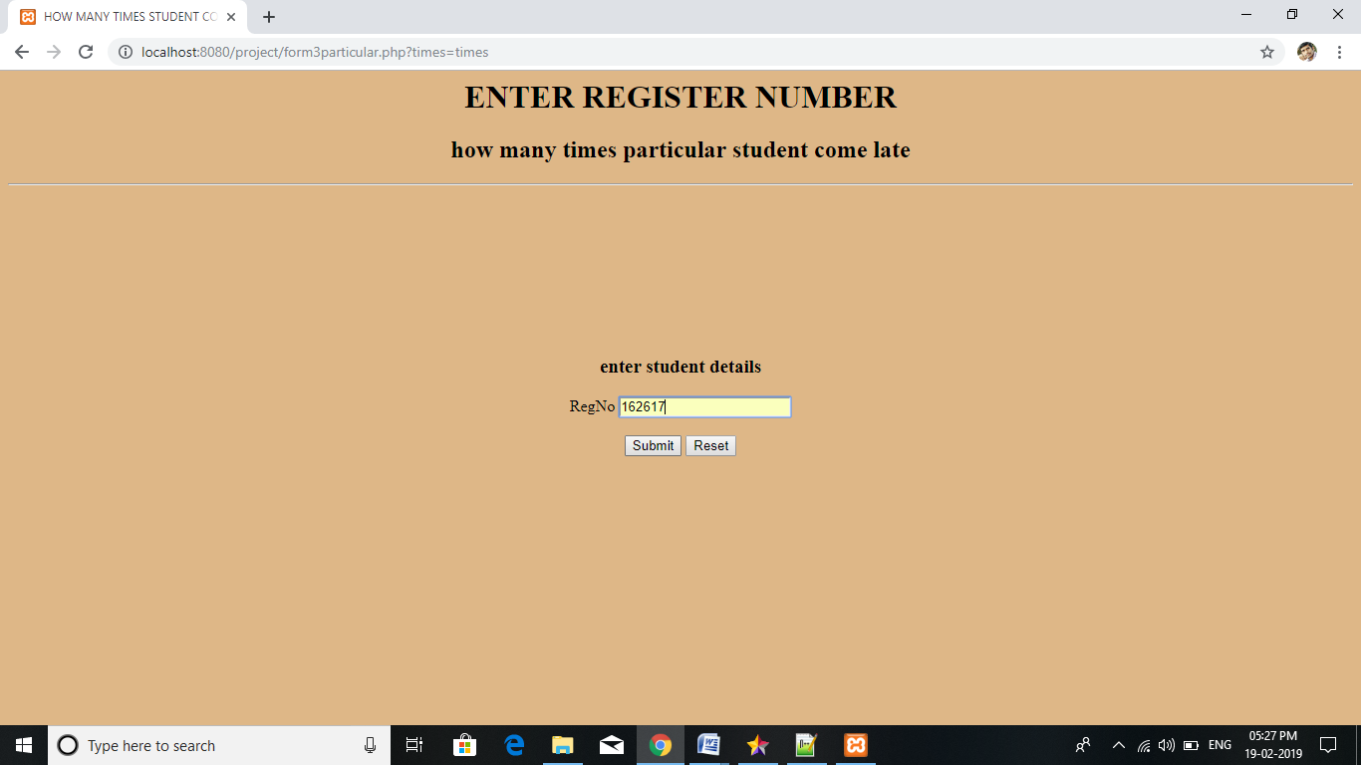

* 1. **The following output will be displayed.**

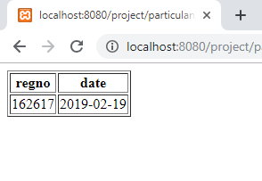

* 1. **Then again go to the introduction website, then click the ‘DISPLAY MORE THAN 3 TIMES ‘, after clicking one website will open then click DISPLAY button to know how many students are coming late more than 3 times.**



9.After clicking the DISPLAY button..

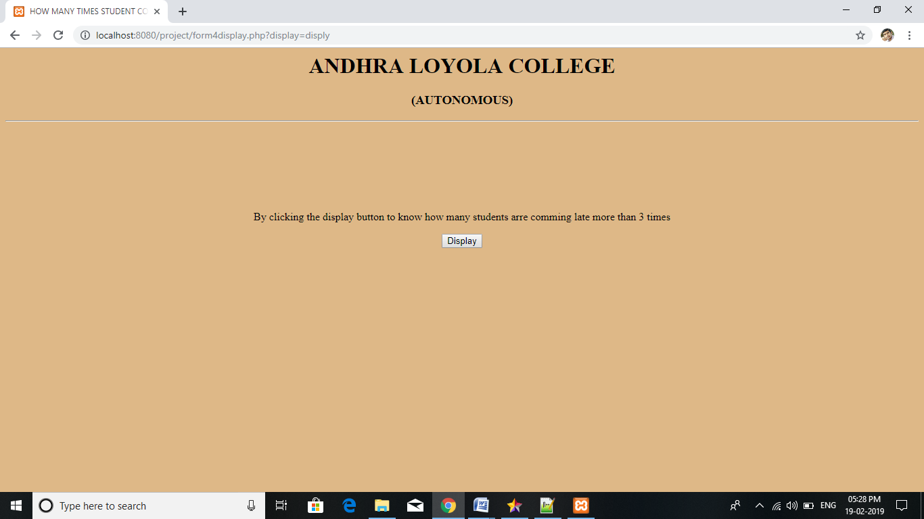

10.By clicking DISPLAY button the following output will displayed. 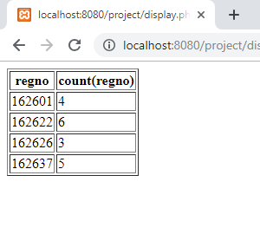

**CHAPTER 6**

CONCLUSION AND FUTURE SCOPE

6.1 CONCLUSION

Any organization need to maintain late commers students database and also updating, manipulating every time, but our designed project has to give support to the management about the late commers details. who are coming late every day to the college. I hope that this project make useful to college administration.

We have utilized the powerful database management, data retrieval and data manipulation. which makes the data entered in the website reliable and stores it all securely. We will provide more ease for managing the data than manually maintaining in the documents. Our work is useful for saving valuable time and reduces the huge paper work.

6.2 FUTURE SCOPE

The scope of the project is as follows:

* To learn about the stages of building a software project, like requirements, design, execution, testing and deployment.
* To learn about web page development and database connectivity between client side and server side in detail.
* To create a prototype web site focusing on one of the many problems that arises within maintaining student records.

**CHAPTER 7**

**REFERENCES**

To design this project we used some sources to write code and design and implementing to this project

[**http://www.bing.com/search?FORM=INCOH2&PC=IC06&PTAG=ICO-a8a9d331851edc13&q=w3schools+html**](http://www.bing.com/search?FORM=INCOH2&PC=IC06&PTAG=ICO-a8a9d331851edc13&q=w3schools+html)

[**www.w3schools.com**](http://www.w3schools.com) **sql**

[**www.w3schools.com**](http://www.w3schools.com) **html**

[**www.w3schools.com**](http://www.w3schools.com) **php**

[**https://www.youtube.com/results?search_query=kothaabhisheiktutorial**](https://www.youtube.com/results?search_query=kothaabhisheiktutorial)

**Balaguruswami text book.**